**Date: 29-03-2025**

**INTERNSHIP LETTER**

This is to certify that **Ms. Mothkur Niharika** was working in our organization

**Ozrit Ai Solutions** as **UI Developer Intern** from **27.01.2025 to 27.03.2025.**

We hereby certify that her performance was good during the tenure.

Her contribution to the organization and its success will always be appreciated.

We wish her all the best in her future endeavors.

**For Ozrit Ai Solutions.**

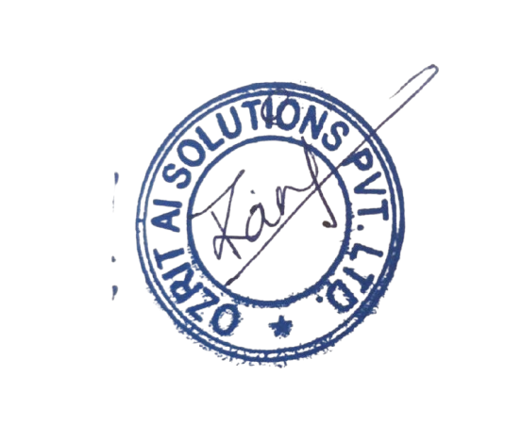

**Rani Kumari**

**HR & Admin Executive**